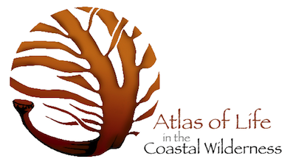
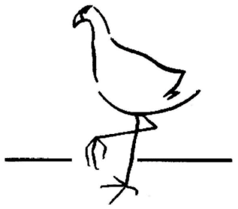

Dear Pambula resident,
I am writing to invite you to the upcoming Panboola Bioblitz. A Bioblitz is an event where scientists, naturalists and community members come together to see how many species of living creatures they can identify over a short period of time. The two day event will be held at the Panboola Wetlands where over 40 different surveys will be conducted. These include but are not limited to insect, plant, bird, bat and mammal surveys. The best way to secure your spot on a survey is to sign up by following the Panboola Bioblitz prompts on the Atlas of Life in the Coastal Wilderness website (www.alcw.org.au). Otherwise, feel free to venture down to the Panboola Centre on either the 11th/12th April and sign up at the survey registry marquee.
Sincerely yours,
Patrick Tegart
Panboola Centre

