2019 ACSA AGM

Monday 11th November 2019, 1:00 – 2:00pm

Meeting Room 450 | Level 4 Carslaw Building F07 | Eastern Avenue, University of Sydney, NSW 2006

Directions
Meeting Room 450 is located on Level 4 of the Carslaw Building (F07), Eastern Avenue is situated on the south-east side of the central campus, near the northern end of the footbridge crossing City Road from the Wentworth Building.

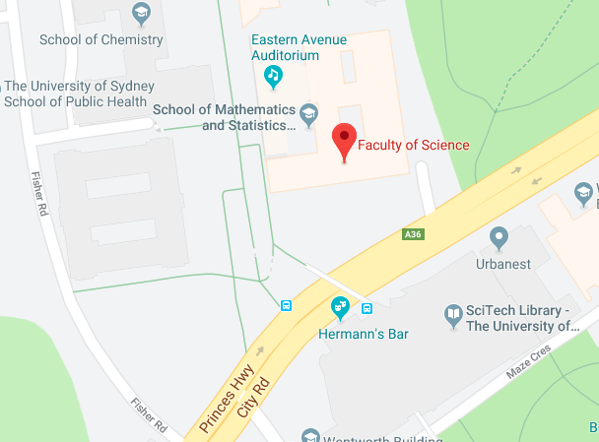

Street level is Level 2 of the Carslaw Building and you will see the Faculty of Science sign on the wall. Catch the one of the blue lifts to Level 4. Once exiting the lift on Level 4 you should turn right and follow signage towards the Dean of Science’s office. Once inside two sets of glass doors, the Meeting Room is on your left.

